Tableau Business Intelligence Report
Author : Aditya Kashyap
Dataset Used: Brazilian E-Commerce Public Dataset (Olist)
Tool Used: Tableau Public Desktop

Objective
In this project, an enterprise-level Business Intelligence system was designed and implemented using Tableau. The purpose of the project was to demonstrate how modern organizations use data visualization and analytics tools to convert raw transactional data into meaningful business insights.
The Brazilian E-Commerce dataset provided by Olist was used as the primary data source. This dataset contains detailed information about customer purchases, product categories, seller information, order payments, and order deliveries. Because the dataset contains multiple relational tables, it is well suited for demonstrating real-world data warehousing and analytics techniques.
During the implementation of this project, the dataset was modeled using a Star Schema architecture and analyzed through several advanced techniques including:
- Data modeling and relational data integration
- Creation of calculated fields and statistical metrics
- Cohort analysis for customer retention evaluation
- Predictive forecasting using time series methods
- Customer segmentation through clustering techniques
- Development of interactive dashboards for decision support
Through these processes, a comprehensive analytical environment was created in Tableau that enables stakeholders to monitor sales performance, analyze customer behavior, and detect operational risks.

Dataset Architecture – Star Schema Design
To enable efficient analytical processing, the dataset was structured using a Star Schema architecture. This schema consists of a central fact table connected to several surrounding dimension tables.
In this project, the olist_order_items_dataset table was used as the central fact table because it contains the transactional records of product purchases. Each row in this table represents an individual item purchased within an order.
The fact table includes important transactional attributes such as:
- Order ID
- Product ID
- Seller ID
- Price of the item
- Freight value
These attributes provide the quantitative data required for business analysis.
Several dimension tables were connected to the fact table using Tableau’s logical relationship model. The following tables were used as dimension tables:
- olist_orders_dataset – contains order timestamps and delivery information
- olist_customers_dataset – stores customer identifiers and geographic information
- olist_products_dataset – contains product categories and product specifications
- olist_sellers_dataset – contains seller location data
- olist_order_payments_dataset – includes payment methods and installment details
These tables were connected using primary and foreign key relationships.
For example:
- The order_id field was used to connect the orders table with the order items table.
- The customer_id field was used to connect orders with customer records.
- The product_id field was used to connect order items with product details. ● The seller_id field was used to connect sellers with the fact table.
This architecture ensured that data duplication was avoided while still enabling flexible aggregation of measures such as total revenue, number of orders, and product sales.
📸 Tableau Data Source page showing the relationship model / schema connections:
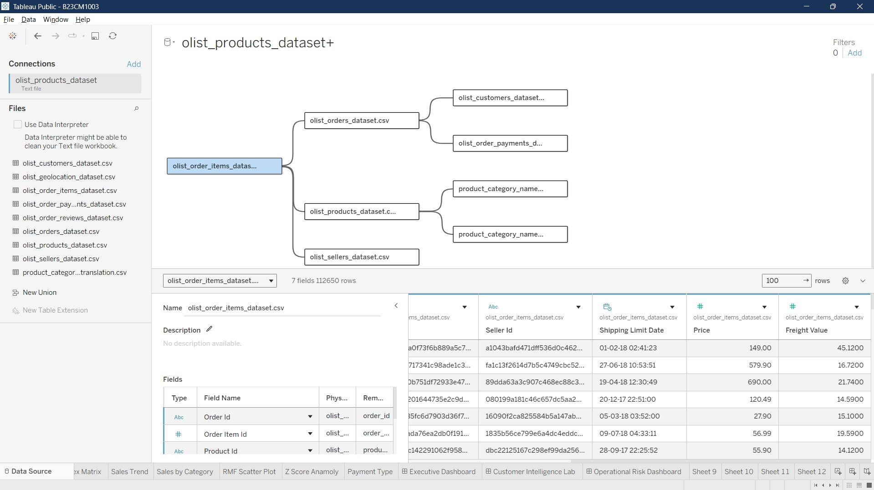
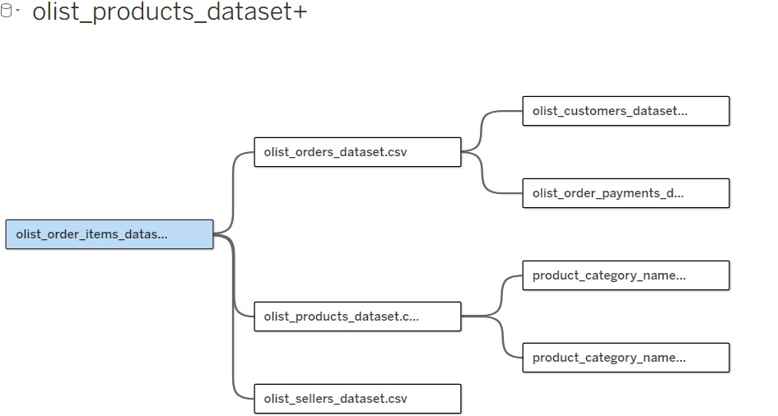

Data Engineering and Preparation
Before performing analytical tasks, several data engineering techniques were applied to ensure that the dataset was suitable for business intelligence analysis.

Creation of Surrogate Keys
In many transactional datasets, a single order may contain multiple products. Therefore, the order ID alone cannot uniquely identify a row in the fact table.
To solve this issue, a surrogate key was created by combining the order ID with the order item sequence number.
The following calculated field was created:
[order_id] + "_" + STR([order_item_id])

This surrogate key ensured that every order item record was uniquely identifiable.
📸 Tableau calculated field window showing the surrogate key creation:
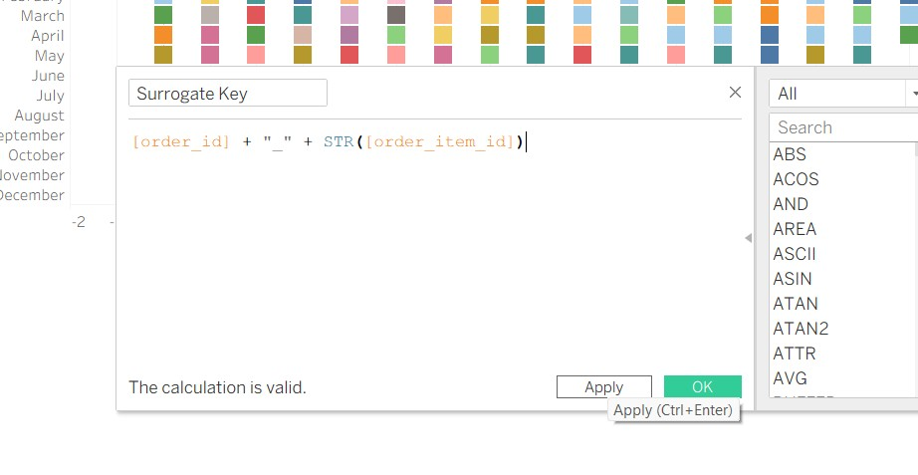

3.2 Handling Slowly Changing

Dimensions (SCD Type 2)
In real-world data warehouses, dimension tables often change over time. For example, customer location or seller information may be updated.
To conceptually simulate Slowly Changing Dimensions Type 2, the historical timestamps associated with orders were used to track customer behavior over time.
By using the order_purchase_timestamp field, historical records of customer transactions were preserved, allowing temporal analysis of purchasing patterns.
This approach enabled the dataset to retain historical context while performing analytical queries.
📸 Orders dataset fields highlighting timestamp columns:
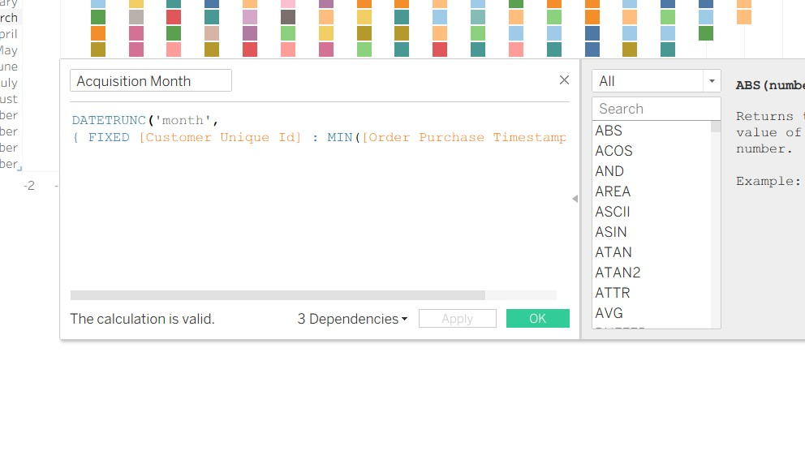

3.3 Live vs Extract Connections and

Hyper Engine
Two types of data connection methods are supported in Tableau:

Live Connection
In a live connection, Tableau queries the underlying data source directly. Every visualization request triggers a query to the database.
While this ensures real-time updates, performance may be slower when working with large datasets.

Extract Connection
In this project, an Extract connection was used. Tableau created a compressed local copy of the dataset using the Hyper Engine.
The Hyper Engine provides several advantages:
- Columnar data storage
- Efficient compression algorithms
- Parallel query processing
- High-speed in-memory analytics
As a result, dashboard performance was significantly improved when compared to live queries.
📸Tableau extract connection settings:


Advanced Analytical Calculations
Several advanced analytical techniques were implemented in Tableau to derive deeper insights from the dataset.

Level of Detail (LOD) Expressions
LOD expressions allow calculations to be performed at a specific level of granularity independent of the current visualization.
In this project, LOD expressions were primarily used to compute Customer Lifetime Value.
The following FIXED LOD expression was implemented:
{ FIXED [customer_unique_id] : SUM([price]) }

This expression calculates the total revenue generated by each customer regardless of the level of aggregation used in the visualization.
Three types of LOD expressions are supported in Tableau:
- FIXED – performs calculations at a fixed dimension level
- INCLUDE – adds dimensions to the calculation scope
- EXCLUDE – removes dimensions from the current scope
Among these, the FIXED expression was most suitable for computing customer-level metrics.
📸Tableau calculated field showing LOD expression:
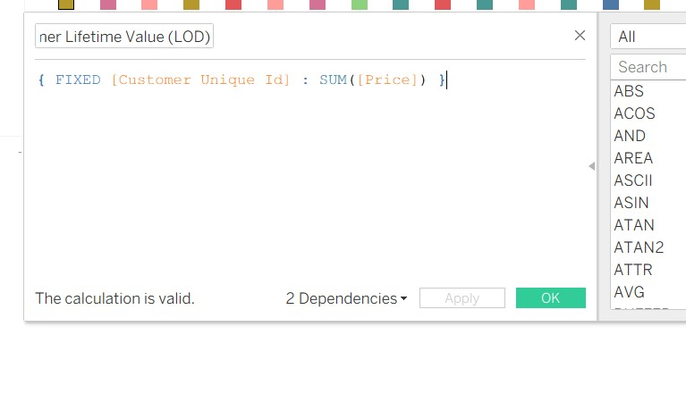

Cohort Analysis
Cohort analysis was performed to evaluate customer retention patterns.
Customers were grouped based on their first purchase month, referred to as the Acquisition Month.
The acquisition month was calculated using the following expression:
DATETRUNC('month',
{ FIXED [customer_unique_id] : MIN([Order Date]) })

The Cohort Index was then calculated to determine how many months had passed since the first purchase.
DATEDIFF('month',
[Acquisition Month],
[Order Month])

Using these fields, a Cohort Heatmap was created. The heatmap visualizes how customer retention changes over time.
📸Cohort heatmap visualization:
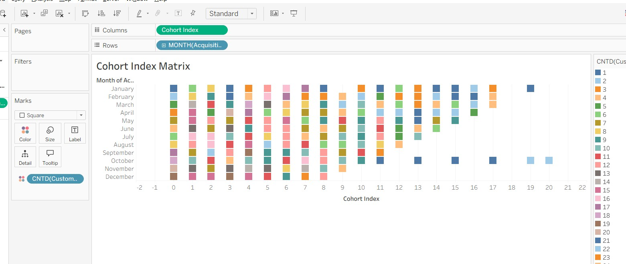

Statistical KPIs
Several statistical metrics were implemented to analyze sales performance.

3-Month Moving Average
The following formula was used to smooth fluctuations in monthly sales:
WINDOW_AVG(SUM([price]), -2, 0)

This metric calculates the average sales over the current month and the previous two months.
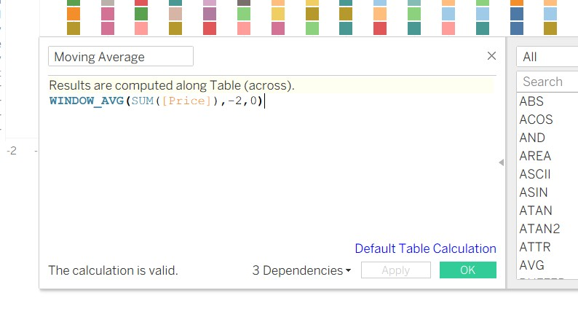
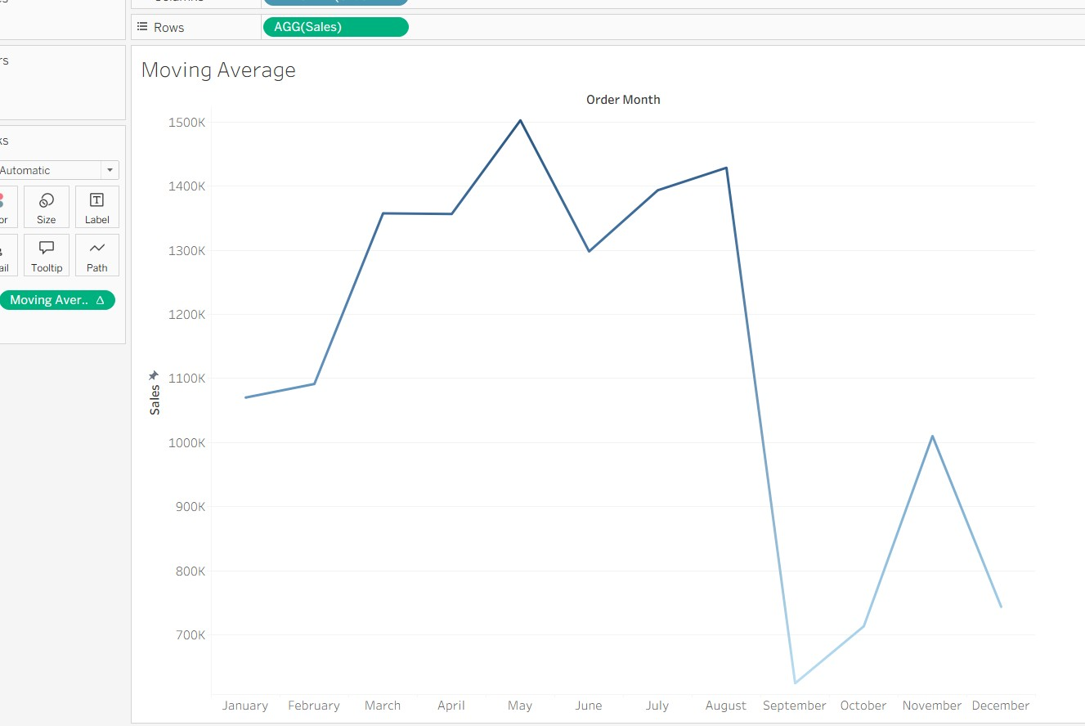

Z-Score Anomaly Detection
An anomaly detection mechanism was implemented using Z-Score calculations.
(SUM([price]) - WINDOW_AVG(SUM([price])))
/
WINDOW_STDEV(SUM([price]))

If the Z-Score exceeded ±2, the corresponding data point was flagged as an anomaly.
This technique allowed unusual sales spikes or drops to be identified.
📸 Z-Score anomaly detection chart:
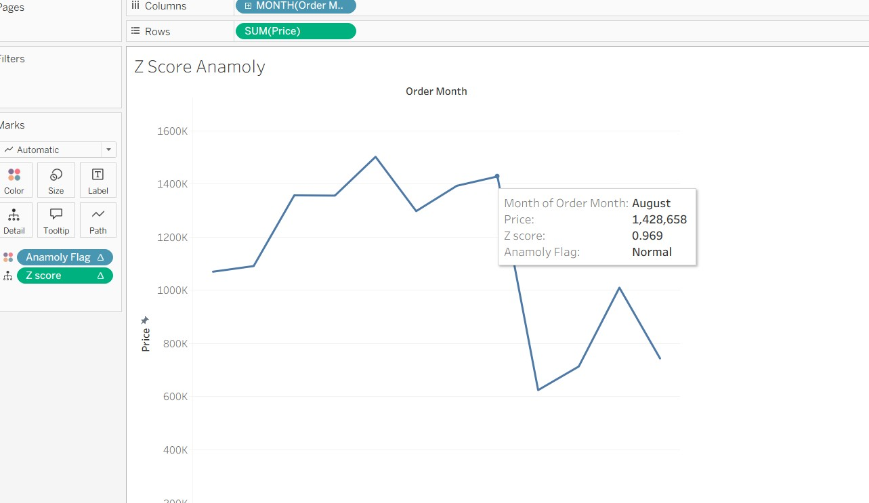

Predictive Forecasting
Predictive forecasting was implemented using Tableau’s built-in Exponential Smoothing (ETS) algorithm.
Historical monthly sales data was analyzed to generate predictions for future sales.
Tableau automatically detects seasonality patterns and trend components in the data.
To evaluate forecasting accuracy, the Mean Absolute Percentage Error (MAPE) metric was calculated using:
ABS([Actual] - [Forecast]) / [Actual]

This metric measures the deviation between predicted and actual values.
📸Forecast visualization with prediction bands:
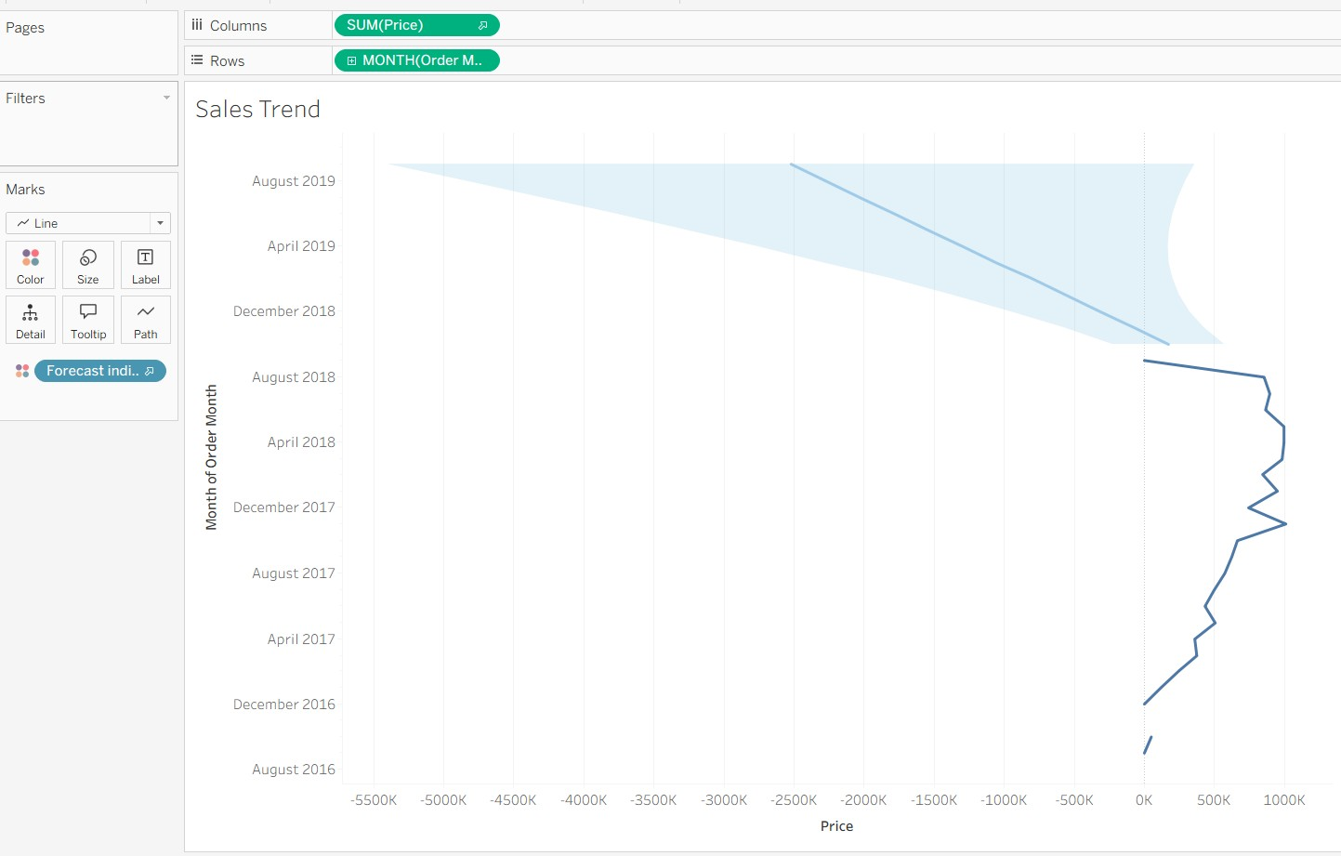

Machine Learning Concepts

K-Means Clustering
Customer segmentation was performed using Tableau’s built-in clustering algorithm.
Customers were plotted using two primary metrics:
- Purchase Frequency
- Monetary Value
Tableau automatically grouped customers into clusters using the K-Means clustering algorithm.
These clusters represent different types of customers such as:
- High value customers
- Loyal customers
- Occasional buyers
- Low engagement customers
📸Cluster scatter plot visualization:
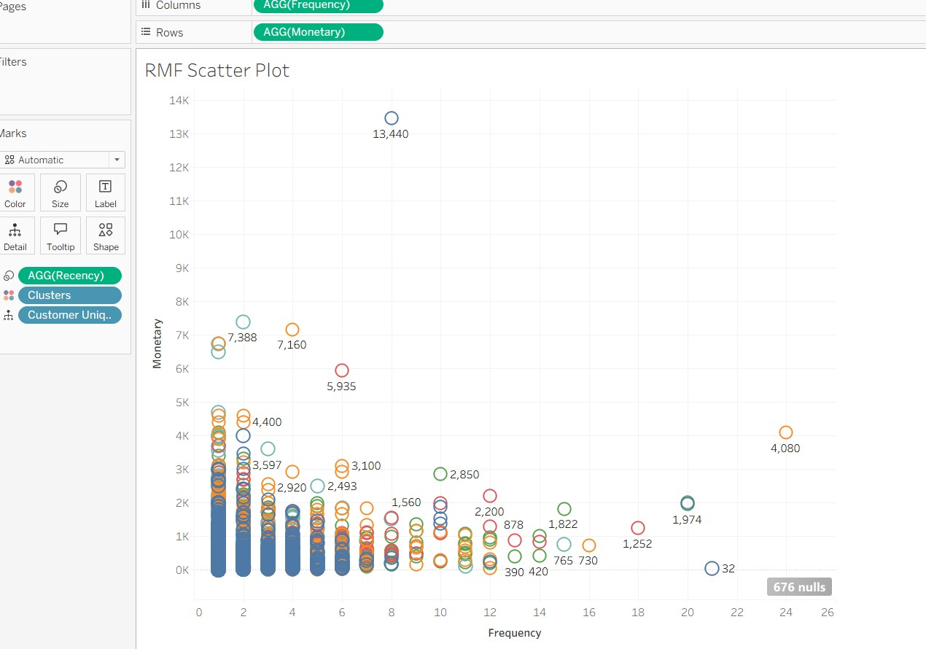

RFM Segmentation
RFM analysis evaluates customer value based on three metrics:
Metric | Description
Recency | How recently the customer made a purchase
Frequenc  y | Number of purchases
Monetary | Total spending
Customers were assigned scores based on these metrics and categorized into segments.
This segmentation helps businesses identify high-value customers and develop targeted marketing strategies.
📸 RFM segmentation visualization:
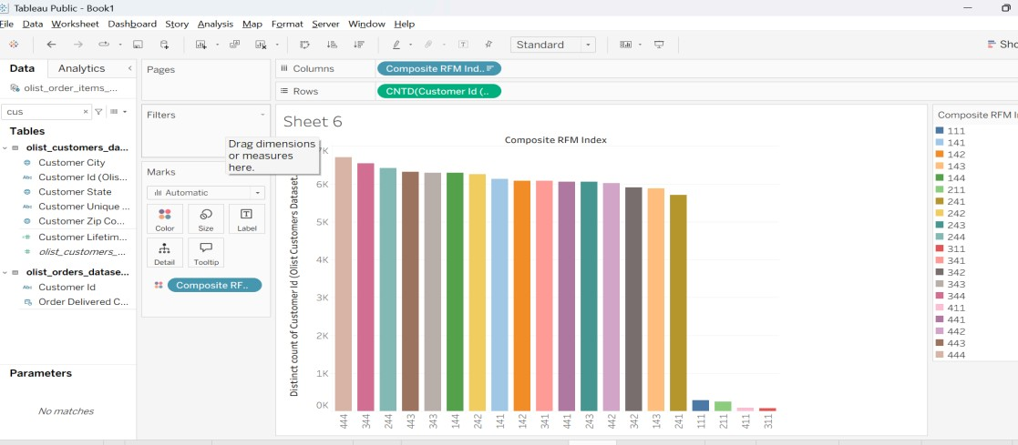

Dashboard Design
Three dashboards were created to present the analytical results.

Executive Control Panel
This dashboard provides a high-level overview of business performance.
Key components include:
- Total Sales KPI
- Total Orders KPI
- Average Order Value
- Monthly Sales Trend with Forecast
- Sales by Geographic Region
- Top Product Categories
Interactive filters were added to allow users to explore the data by year, product category, and geographic location.
📸Executive dashboard:
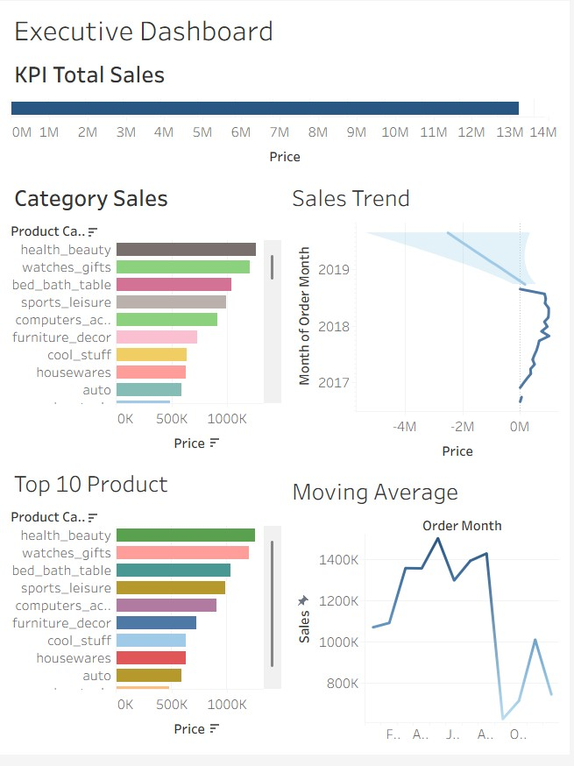

Customer Intelligence Lab
This dashboard focuses on customer behavior and retention patterns.
It includes:
- Cohort Retention Heatmap
- Customer Lifetime Value distribution
- RFM segmentation scatter plot
- Payment method analysis
This dashboard helps identify customer engagement patterns and retention trends.
📸Customer intelligence dashboard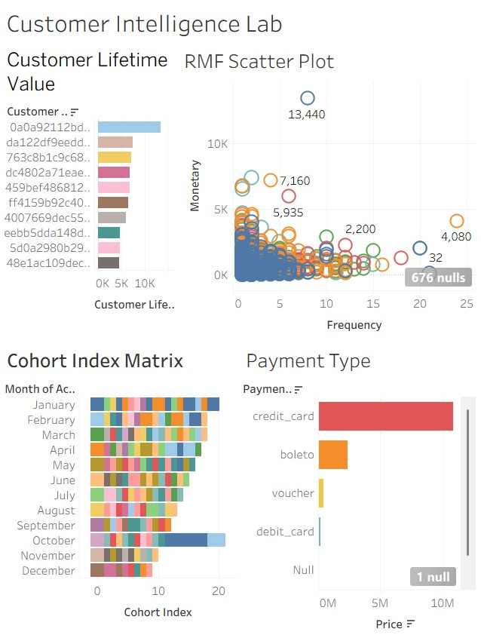

Operational Risk Dashboard
The operational risk dashboard monitors potential business issues.
Key visualizations include:
- Z-Score anomaly detection chart
- Profit leakage analysis
- Monthly sales performance
- Payment trends
This dashboard helps identify operational inefficiencies and unexpected revenue fluctuations.
📸Operational risk dashboard: 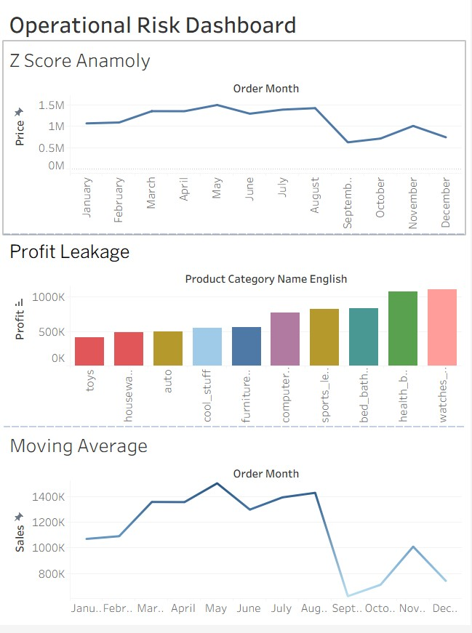

Performance Optimization
To improve dashboard performance, several optimization techniques were applied.

Context Filters
Context filters were used to reduce the dataset size before performing complex calculations such as LOD expressions.

Performance Recording
Tableau’s Performance Recording tool was used to analyze query execution times and dashboard rendering performance.
These insights help identify potential bottlenecks in dashboard performance.
Performance recording result:
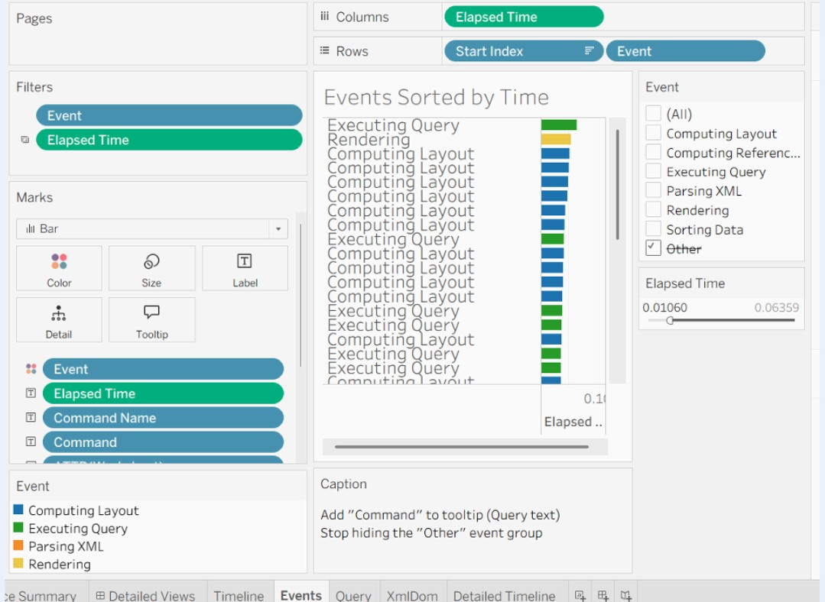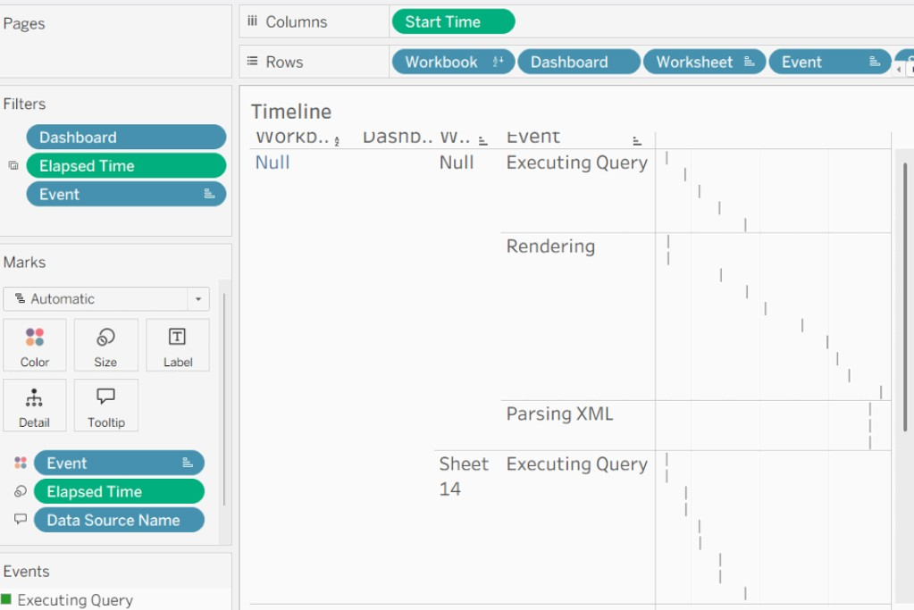
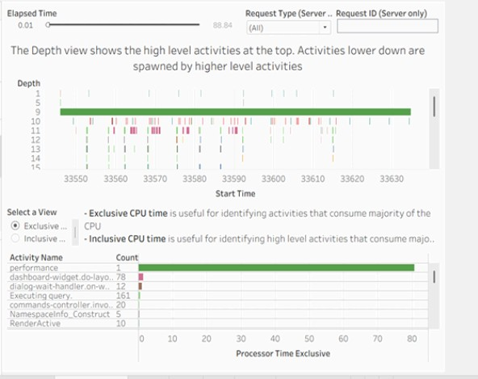

Theoreticals:

1. Explainating Tableau Architecture
Tableau follows a three-tier architecture:
Layer Component
Client Layer Tableau Desktop / Tableau
Public
Application Layer Tableau Server
Data Layer Data Sources / Hyper Engine
The VizQL engine converts drag-and-drop actions into SQL queries and visualizations.

2. Explaining Hyper Engine
Hyper is Tableau’s in-memory database engine designed for high-performance analytics. It uses columnar storage, compression, and parallel processing to accelerate data queries.

3. Differences Between Data Blending and Joining
Feature | Joining | Blending
Level | Row level | Aggregated level
Data Source | Same  source | Different sources
Performanc e | Faster | Slower

4. Explaining LOD Expressions
LOD expressions enable calculations at different granularity levels.
Types include:
- FIXED

- INCLUDE

- EXCLUDE

They allow advanced metrics without creating additional tables.

5. Comparing Tableau with Power BI and Qlik Sense
Tool Strength
Tableau Advanced visualization
Power BI Microsoft ecosystem integration
Qlik Sense Associative data engine

Conclusion
Through this project, a comprehensive Business Intelligence system was successfully implemented using Tableau.
The integration of advanced analytical techniques, predictive forecasting, and machine learning segmentation enabled deeper insights into sales performance and customer behavior.
The dashboards created in this project provide an interactive platform for analyzing e-commerce operations and identifying strategic opportunities for business growth.
This project demonstrates how Tableau can be effectively used to transform complex datasets into meaningful visual insights for decision-making.

